Nicholas Primiano

Problem 1

Problem 2

Problem 3

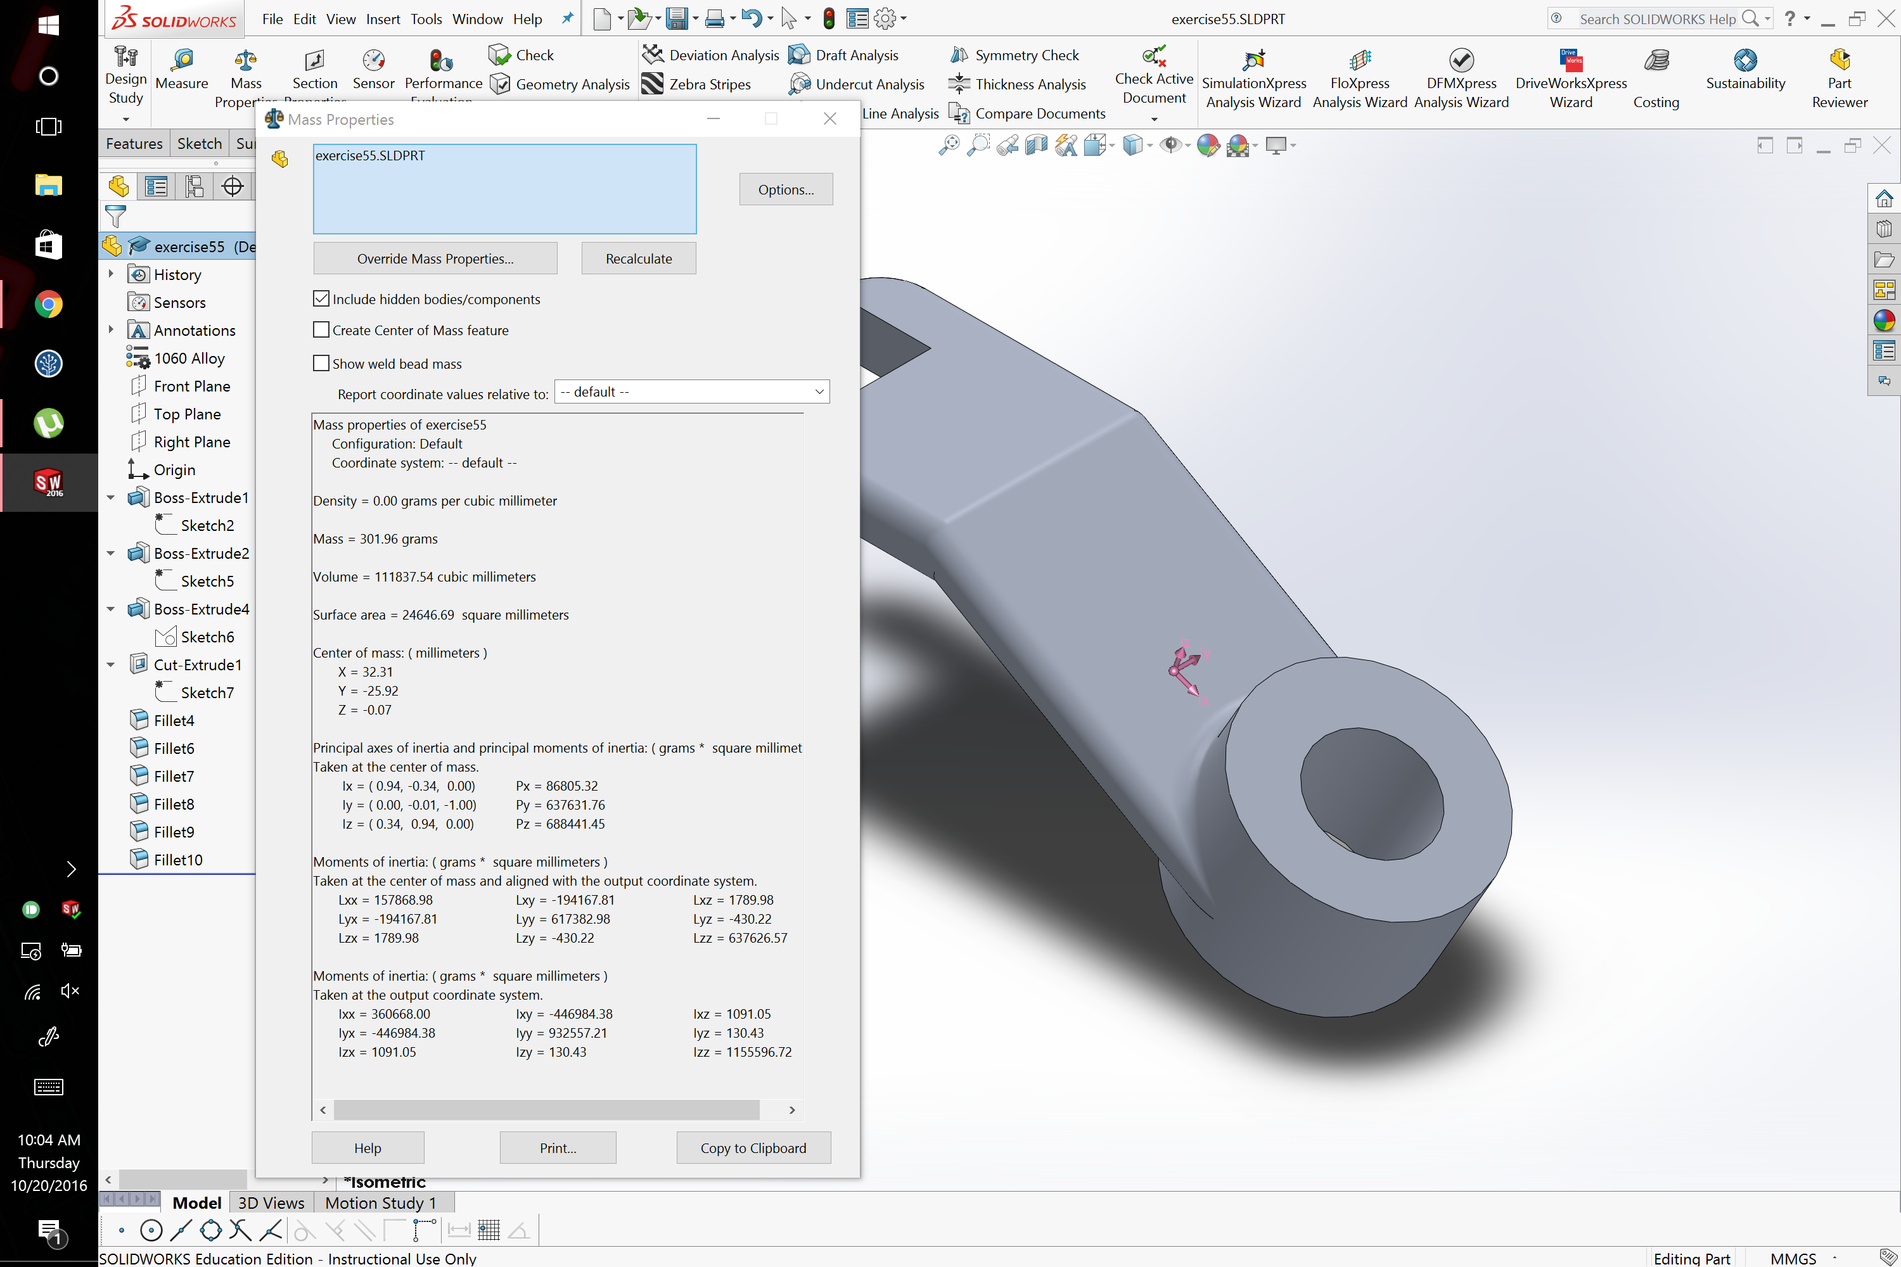

Problem 4

